AWS Deployment Guide for Static Websites
Perpetration
1. Modify Files
Make any necessary changes as per the instructions in “edit_instruction.docx”.
2. Access the Build Folder
Open your build folder (commonly named “dist,” but the name doesn’t matter).
3. Compress Files
• Inside the “dist” folder, select all files by clicking and holding the left mouse button, dragging to highlight them.
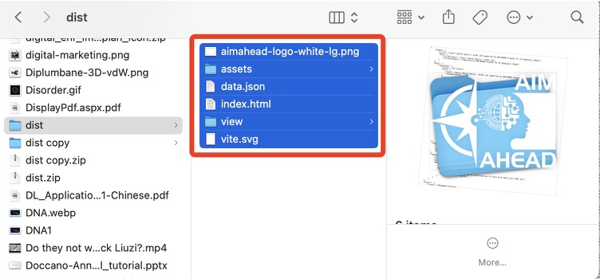
• Right-click on the highlighted files. Then click “Compress” to create a single zip file.

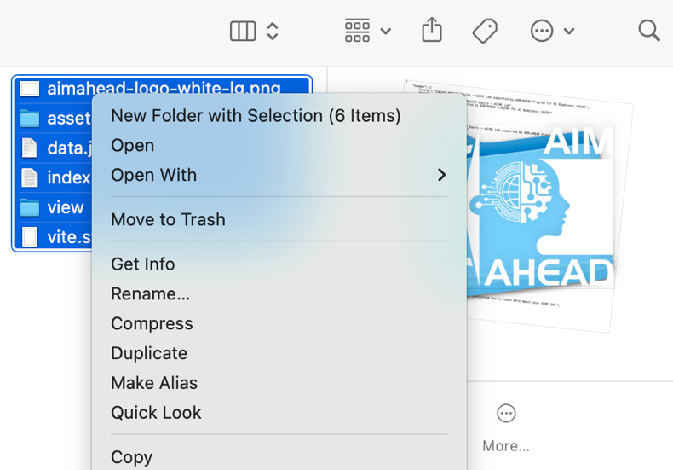
• Once the zip file is created, you can ignore the other files. This zip is all that is needed for deployment.
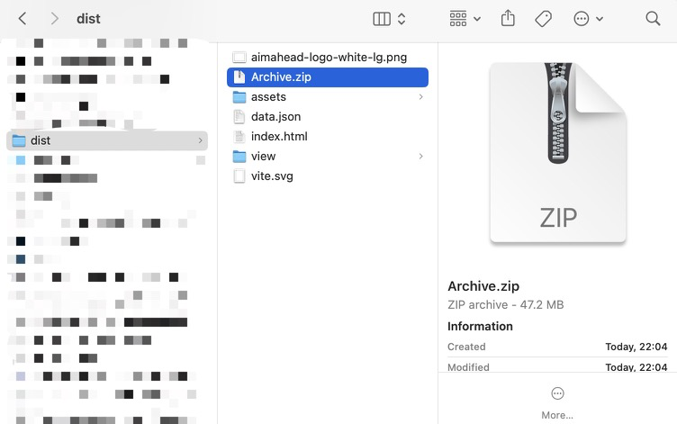

Deployment

1. Log in to AWS Amplify Console
Open a new browser window, go to the AWS Amplify Console, and log in to your AWS account.
2. Start a New Deployment
Click on Deploy an app or Create new app.
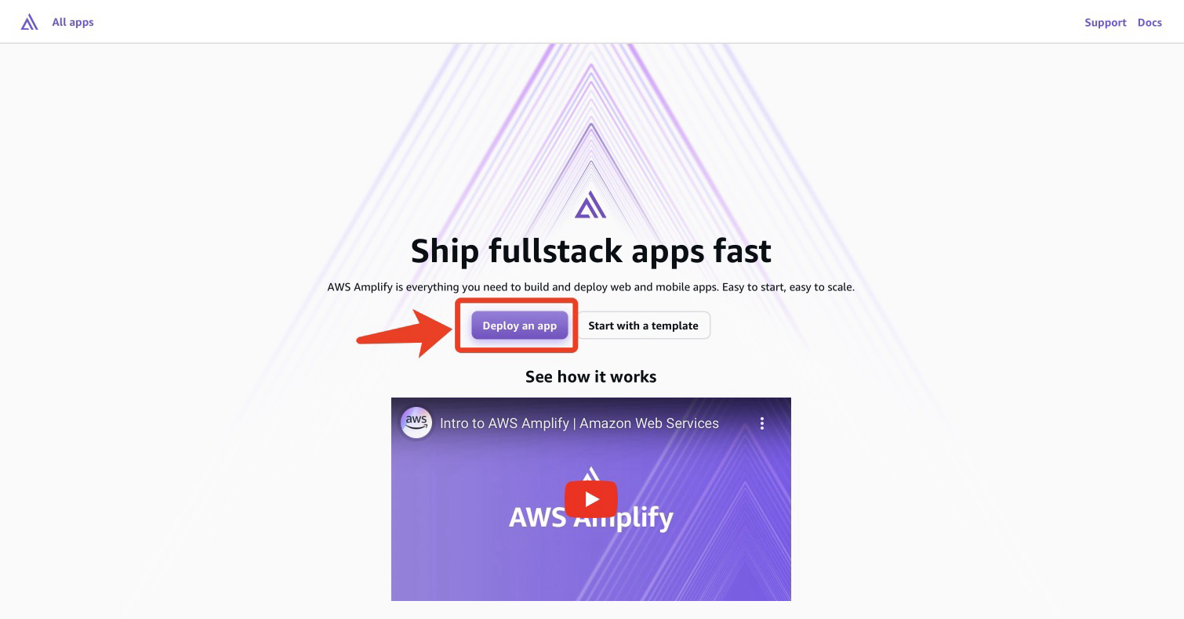
3. Choose Manual Deployment
On the “Start building with Amplify” page, choose Deploy without Git and click Next.
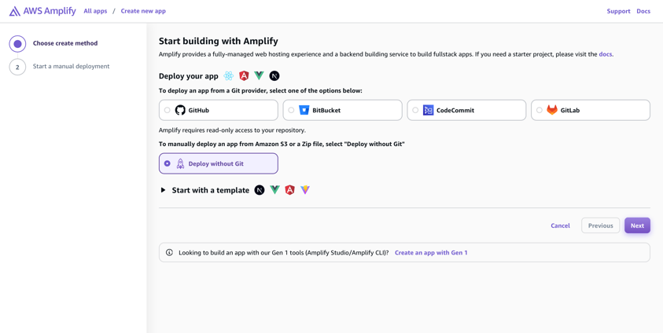
4. Upload Your Zip File
• On the “Start a manual deployment” page, you’ll have options to name your website and branch (these names won’t affect the deployment).
• Upload the zip file you created from the “dist” folder and click Save and deploy.
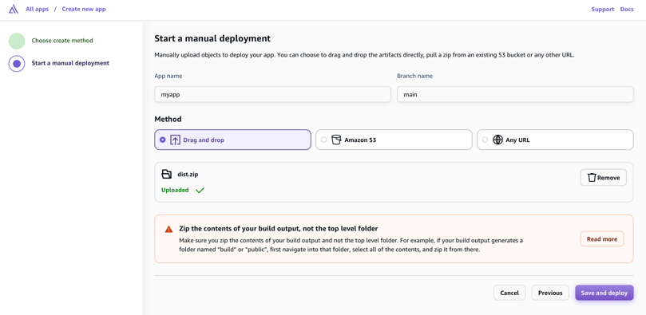
5. Website Live
Once deployment is complete, AWS will provide a URL where your site is now live.
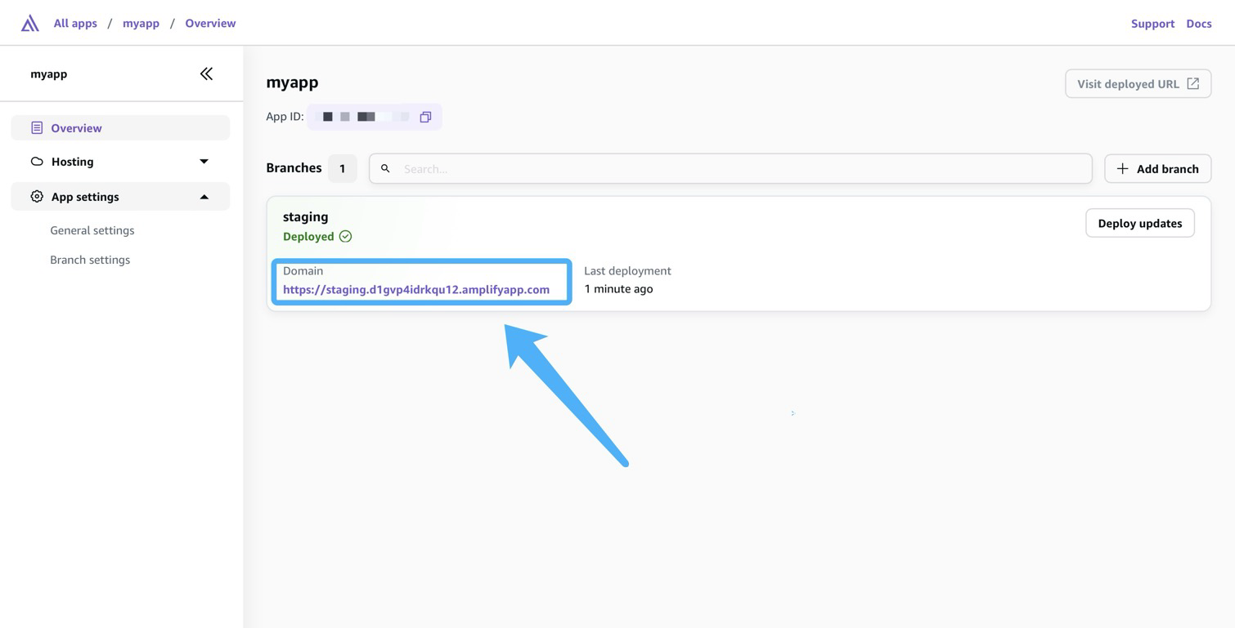
Success!

Your static website is now live—congrats on a successful deployment! 🎉

For additional information, visit AWS Getting Started.

